COMMONWELTH OF MASSACHUSETTS
DEPARTMENT OF THE TRIAL COURT

Middlesex, SS | Superior Court  Civil Action No.: 08-4505

Steven Golub ,  Plaintiff  vs.  Princeton Properties, Inc., and R&R Lawn Maintenance ,  Defendant | )  )  )  )  )  )  )  )  )  )  )  ) | KEEPER OF RECORDS  NOTICE OF TAKING DEPOSITION

TO: | Kenneth J. Butterworth, Esquire  Marcotte Law Firm  45 Merrimack Street  Lowell, MA 01852 | Kenneth J. Butterworth, Esquire  Marcotte Law Firm  45 Merrimack Street  Lowell, MA 01852

Please take notice that commencing at 10:00 a.m. on at Horn & Lauretti, 225 Friend Street, Suite 204 , Boston, MA 02114 the Defendant in this action by its attorney will take the deposition upon oral examination of the KEEPER OF RECORDS, Boston Out Patient Surgical Suites , Medical Records, 840 Winter Street , Waltham, MA 02451-1247 pursuant to Rule 30 of the Massachusetts Rules of Civil Procedure before a Notary Public, in and for the Commonwealth of Massachusetts, or before some other officer authorized by law to administer oaths. The oral examination will continue from day to day until completed. You are invited to attend and cross-examine.

And, you are required to bring with you: Please see attached Schedule A. Please note that if certified records are mailed to and received by Axiom Requisition Copy Service, 447 North Canal Road, Lansing, MI 48917, prior to the deposition date, no one needs to attend the deposition.
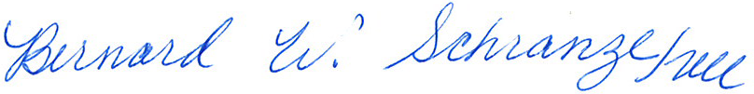

_______________________________________
John M. Horn, Esquire
Horn & Lauretti
225 Friend Street, Suite 204
Boston, MA 02114
Tel.: (617) 589-3000
Dated:

Order No. 01-17576-001

